Analysis of Data Structures

Author: Nitsenko Oleksandr

Introduction
Efficient data structures are fundamental to modern computer science, as they directly influence the performance of algorithms and systems.
This project presents an experimental comparison of four widely used data structures:
AVL Tree
Splay Tree
Hash Table with Separate Chaining
Hash Table with Double Hashing
The aim is to evaluate their performance under different conditions and analyze how their theoretical properties manifest in practice.

Objective
The main objective of this experiment is to:
Compare performance of selected data structures
Evaluate the impact of input size (n)
Analyze behavior under different input distributions
Measure execution time of core operations
The following operations were tested:
INSERT
SEARCH
DELETE

Experimental Setup
Input Scenarios
To simulate different real-world conditions, three scenarios were used:
Sorted Input
Sequential data: 1, 2, 3, 4, 5, ...
Can lead to worst-case behavior in non-balanced structures
Useful for testing structural stability

Reverse Sorted Input
n, n-1, n-2, ...
Another edge case
Often produces different behavior than sorted input
Random Input
random permutation of values
Represents realistic usage
Most important scenario for practical evaluation

Input Sizes
The following dataset sizes were used: 1 000, 10 000, 20 000, 40 000, 60 000, 80 000, 100 000
This allows observation of scalability trends.

Measurement Method
Execution time was measured using the clock() function in C.
The result was normalized as:
average time per operation
Formula:
time per operation = total time / n

Repetition and Averaging
To improve accuracy:
Each test was executed 10 times
Results were averaged
This reduces the impact of:
CPU scheduling noise
Cache effects
Random fluctuations

Benchmark Workflow
For each data structure:
- Generate input data
- Measure INSERT
- Rebuild structure
- Measure SEARCH
- Rebuild structure
- Measure DELETE
This ensures fair comparison.

Output Format
Benchmark results are stored as:
STRUCTURE,SCENARIO,N,OPERATION,TIME
Example:
AVL,SORTED,10000,INSERT,0.123

Where TIME is measured in microseconds per operation.

Visualization
A Python script using matplotlib was implemented to visualize the results.
(The sharp spike at small numbers of elements is not due to the algorithm, but to measurement inaccuracies. When n is small, the runtime is very short, and the result is heavily influenced by overhead—the timer, cache, and system. As n increases, these factors disappear, and the graph reflects the actual complexity. AVL remains O(log n), but the logarithm grows slowly, so the graph appears almost linear.)
Each graph represents:
X-axis → input size (n)
Y-axis → average time per operation
Lines → different data structures
Separate graphs were generated for:

INSERT
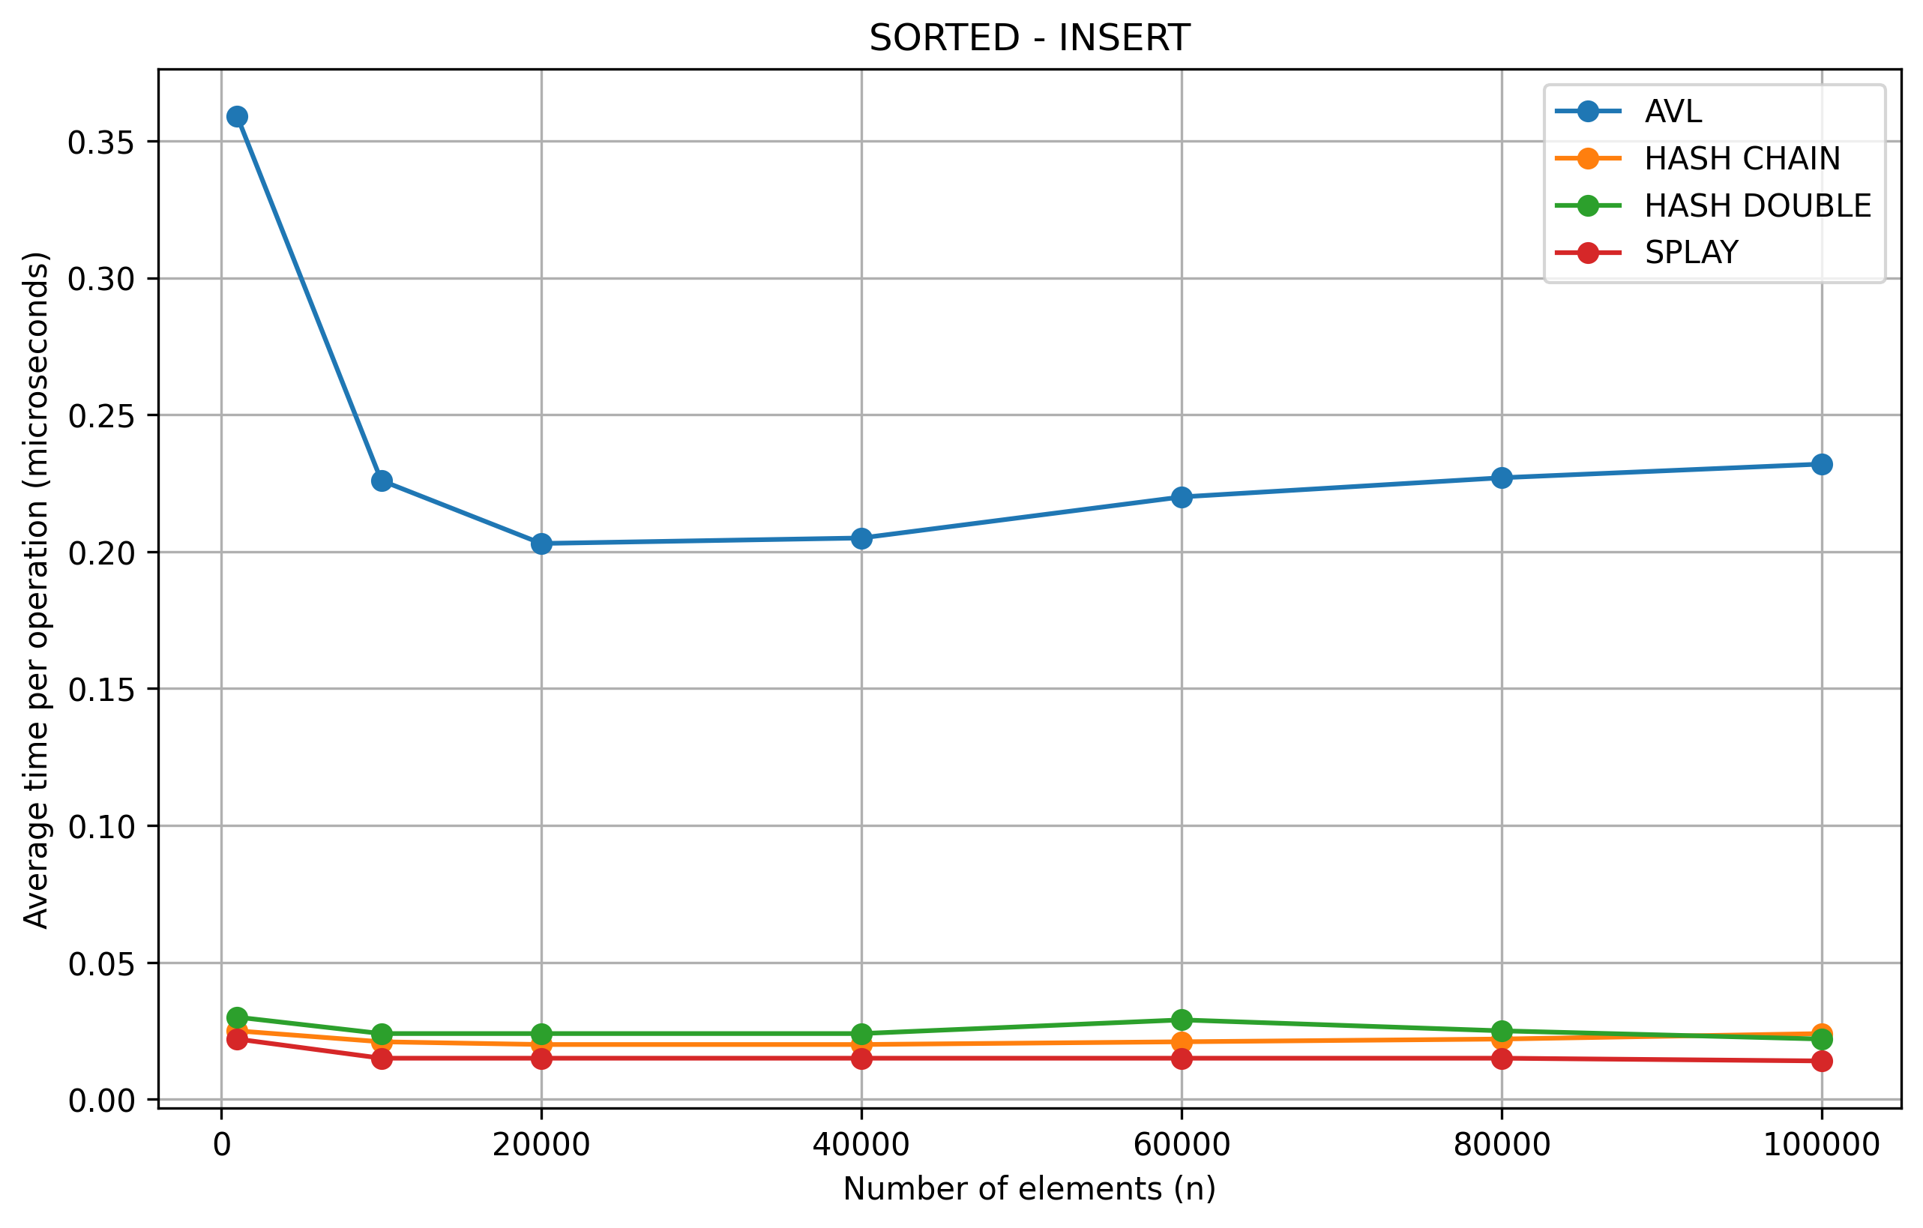
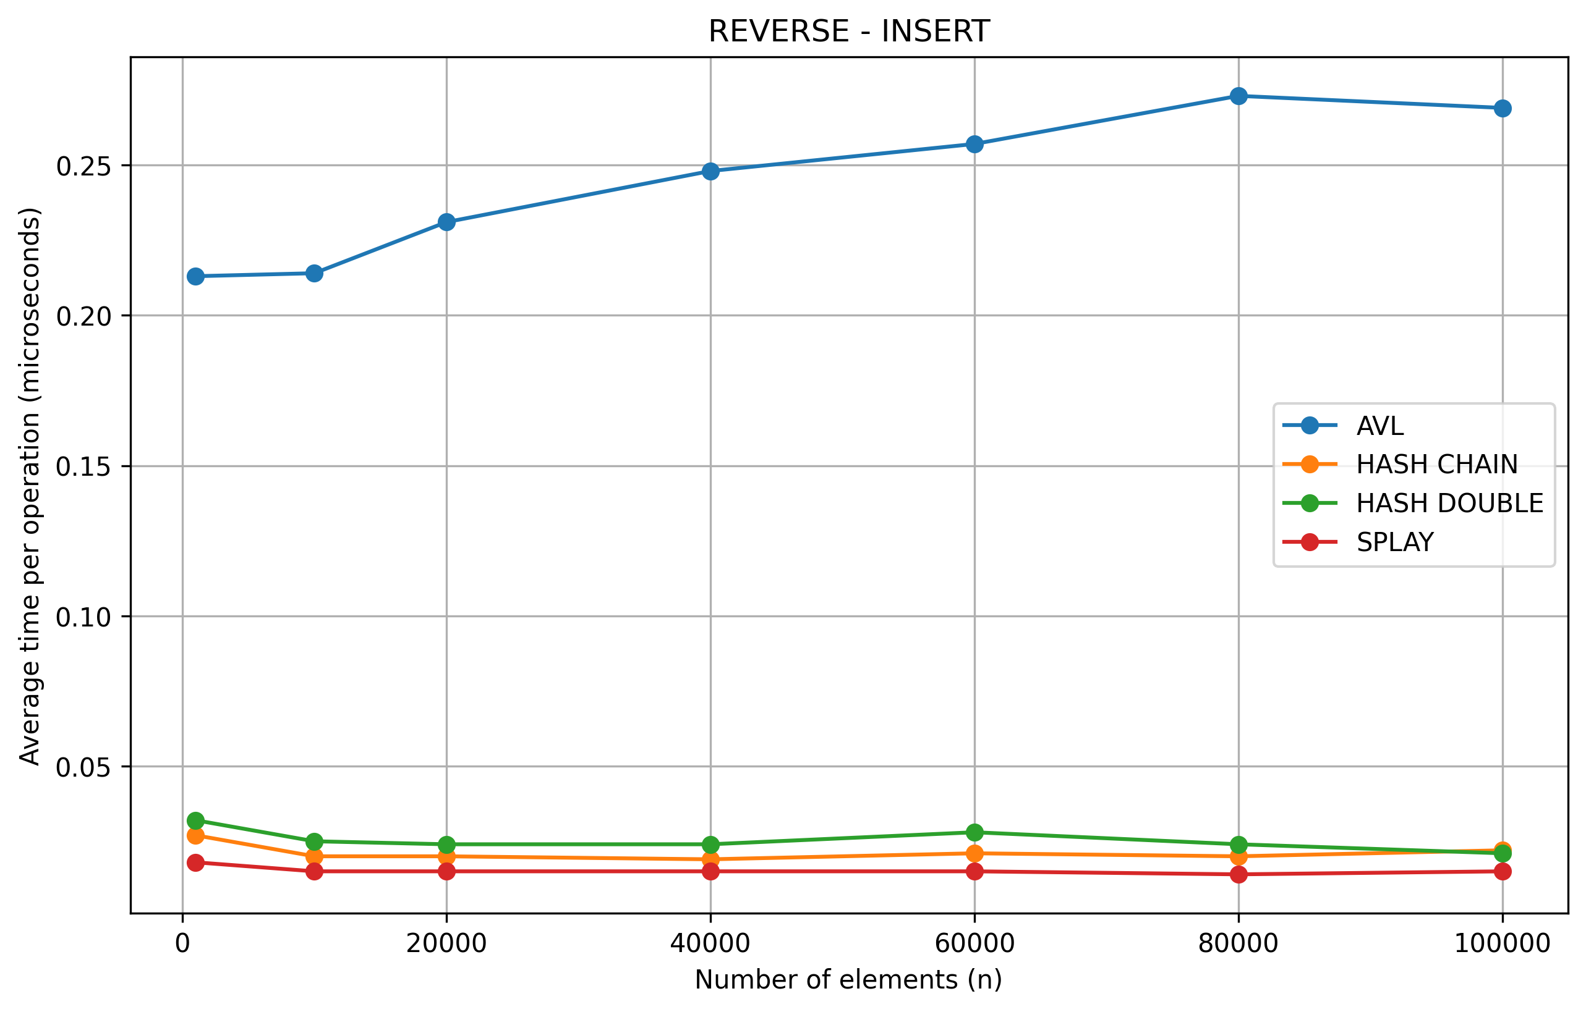
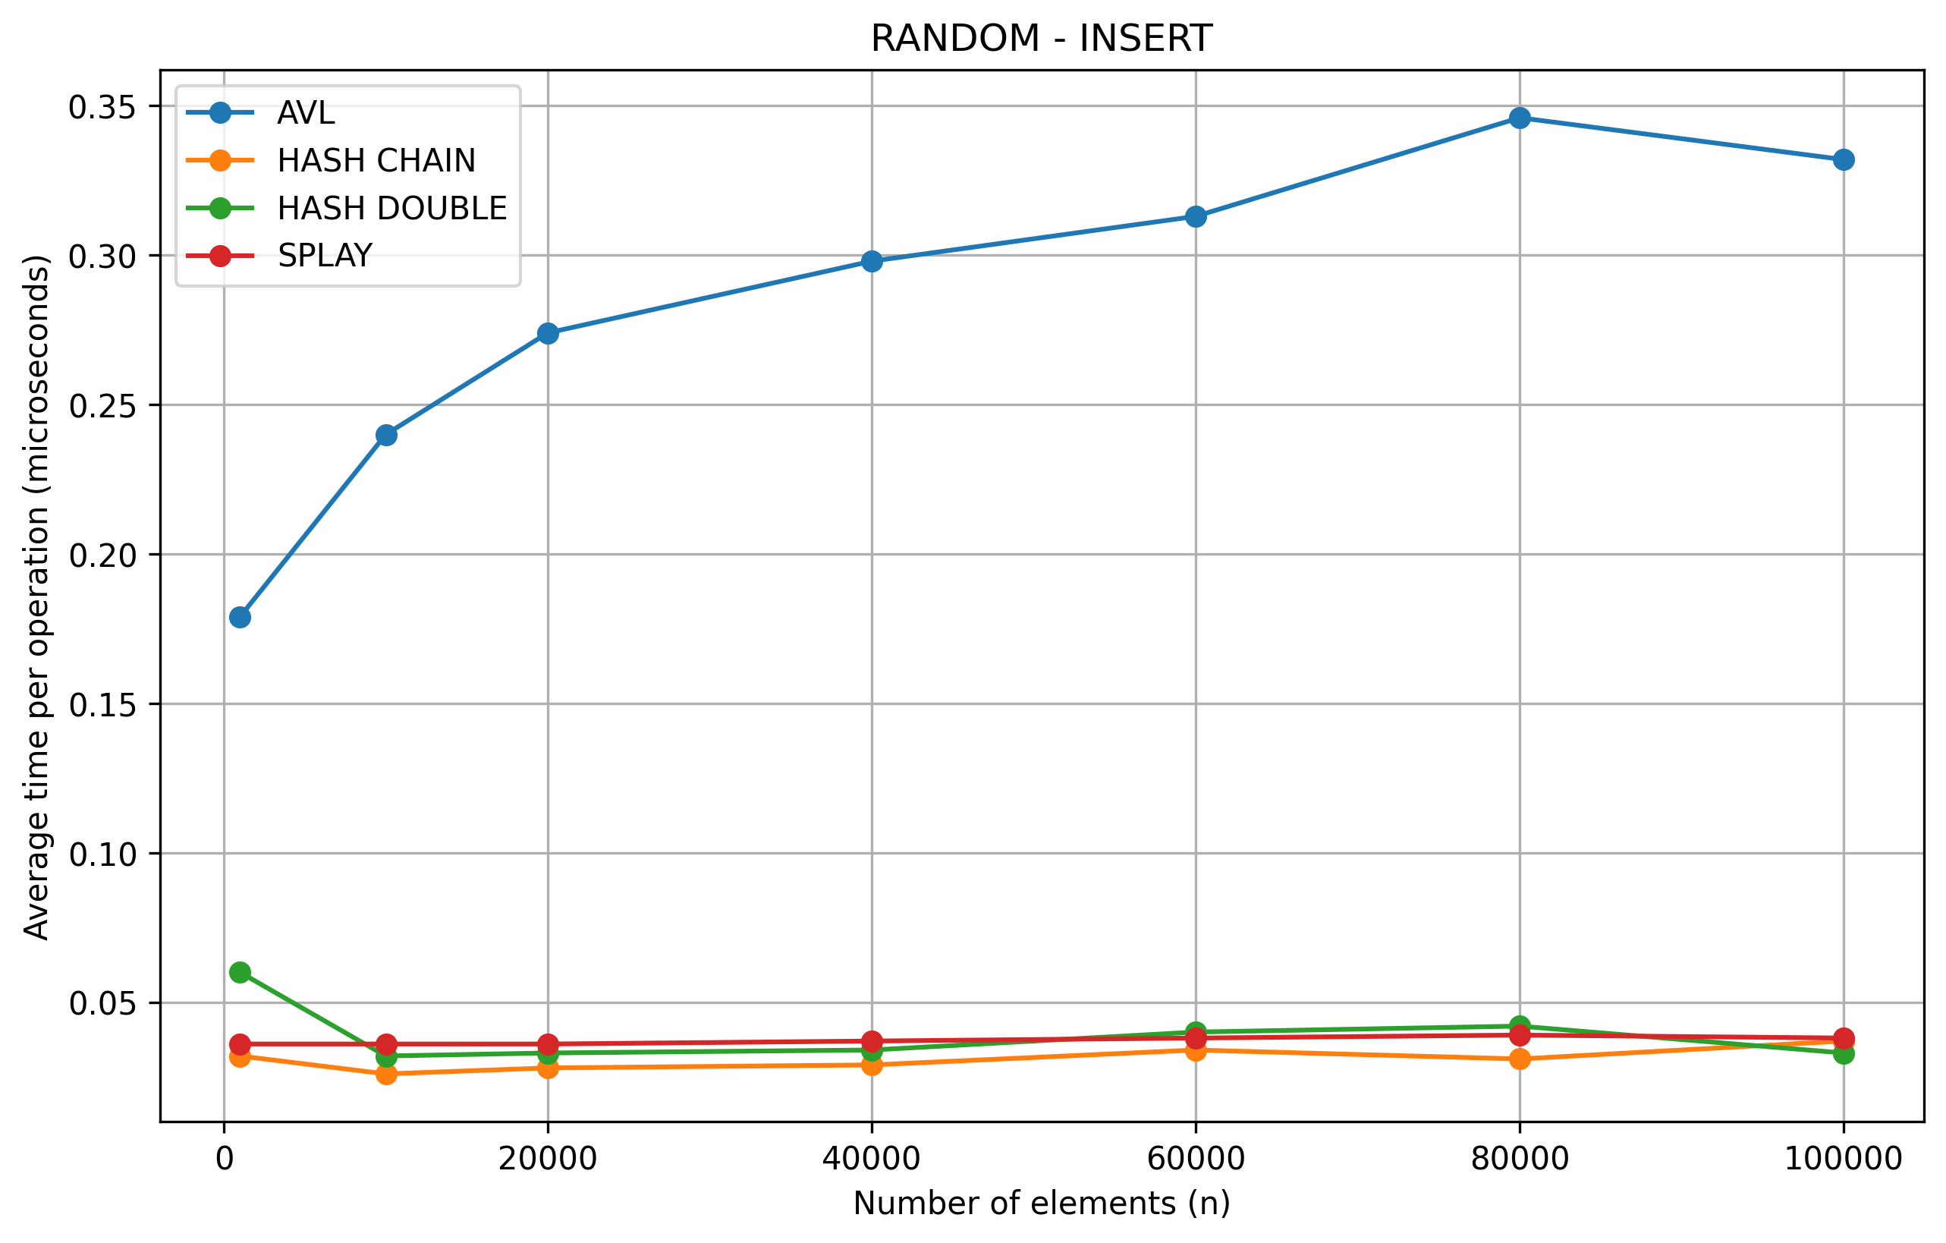

SEARCH
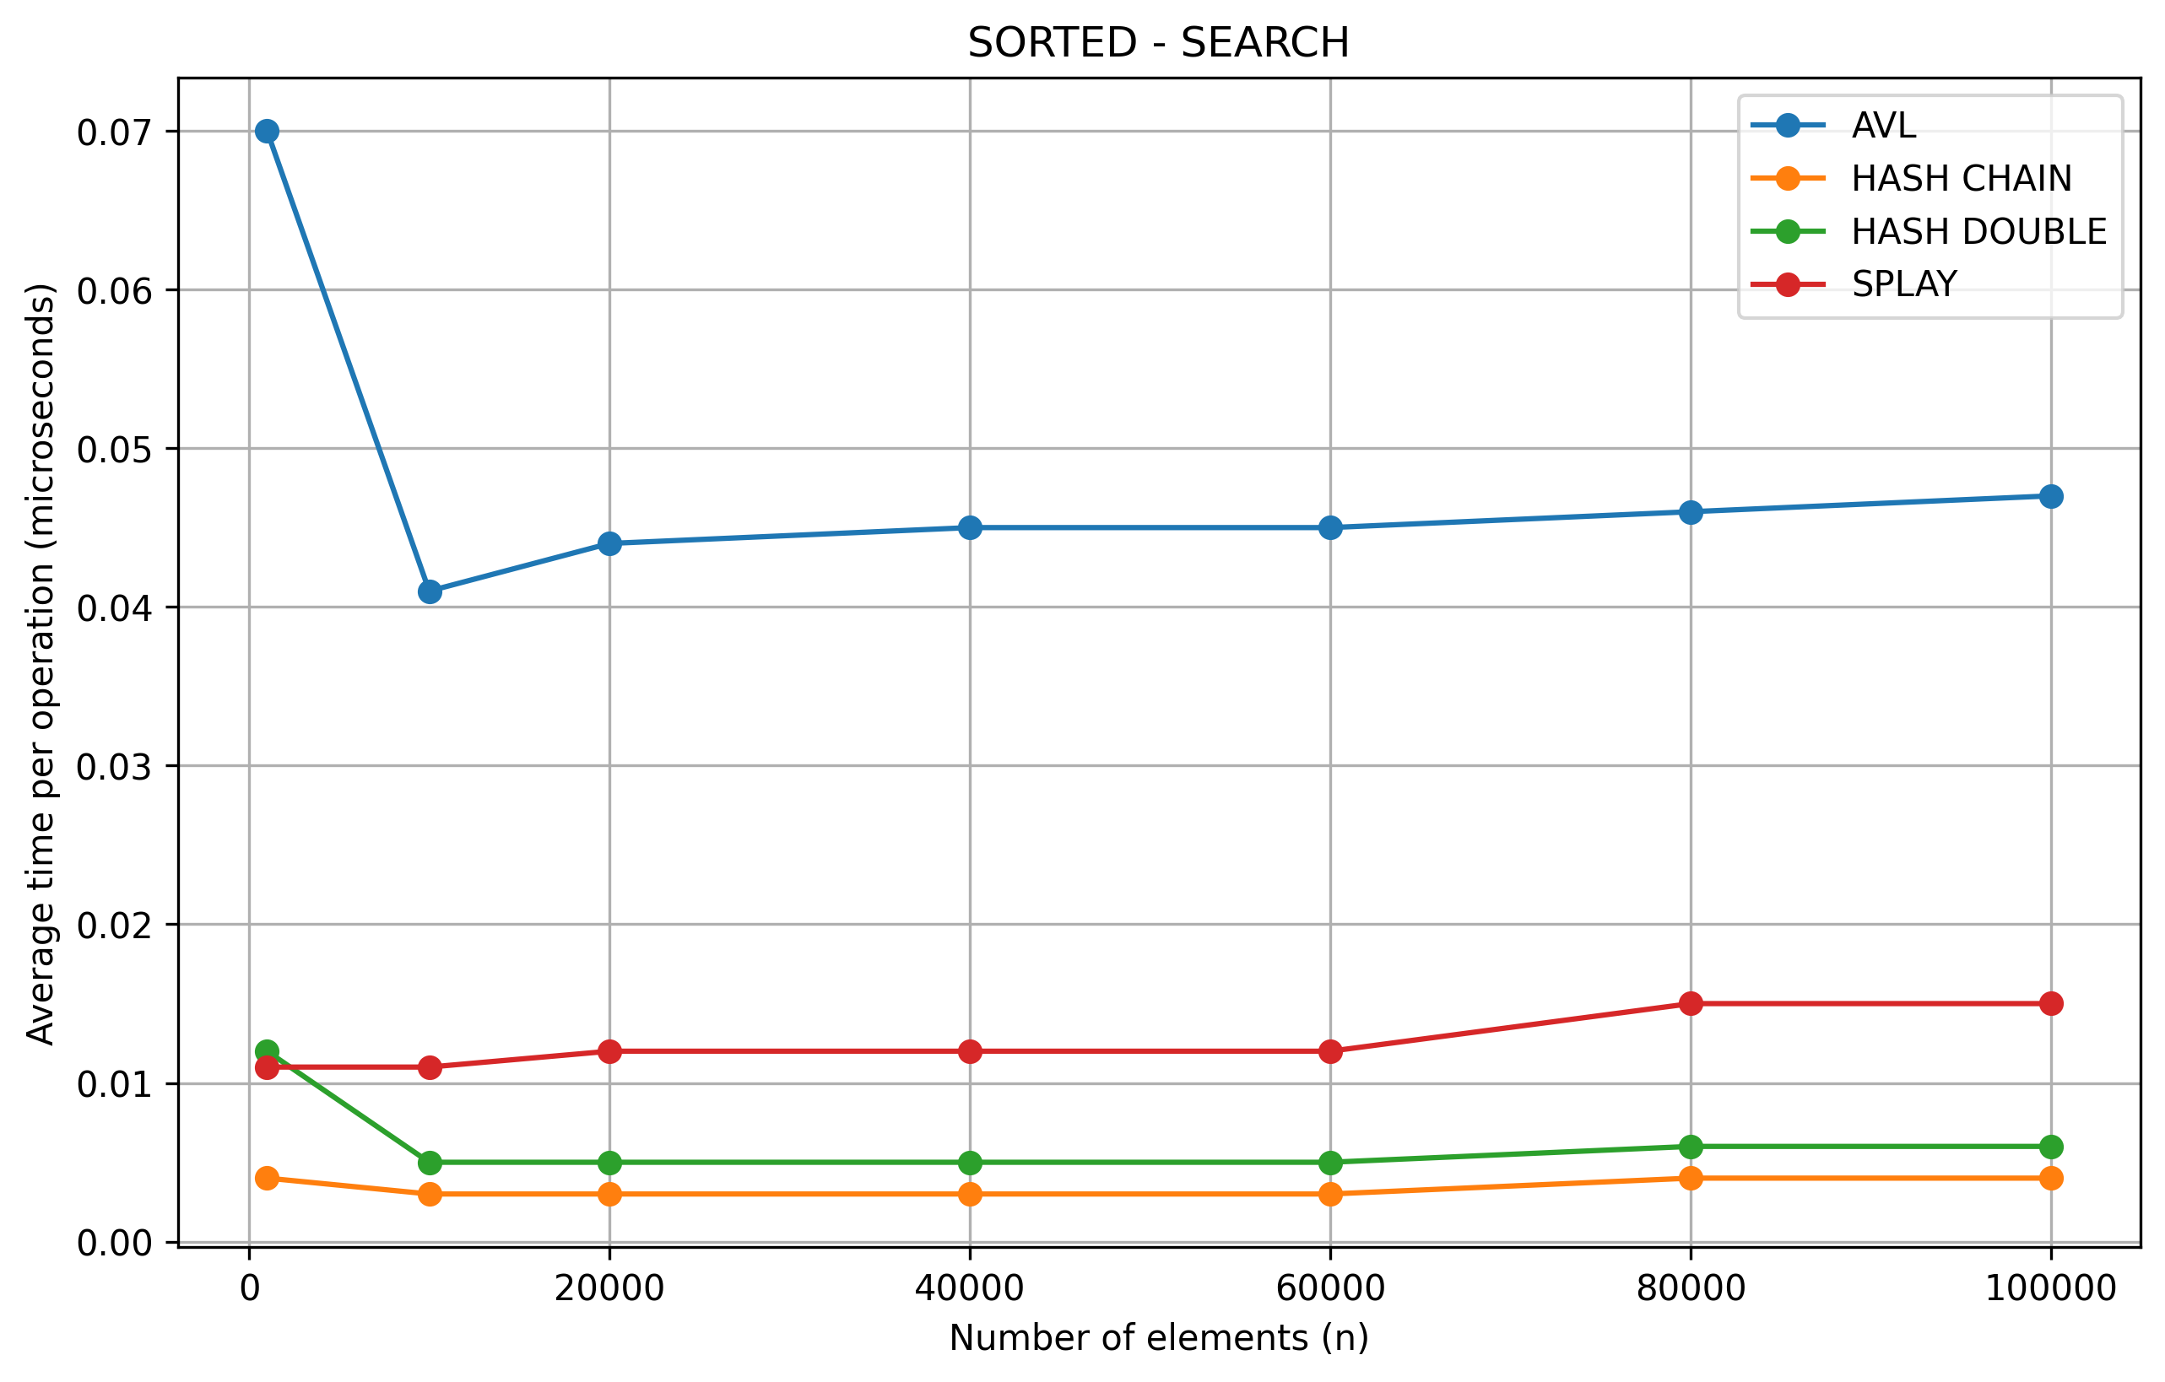
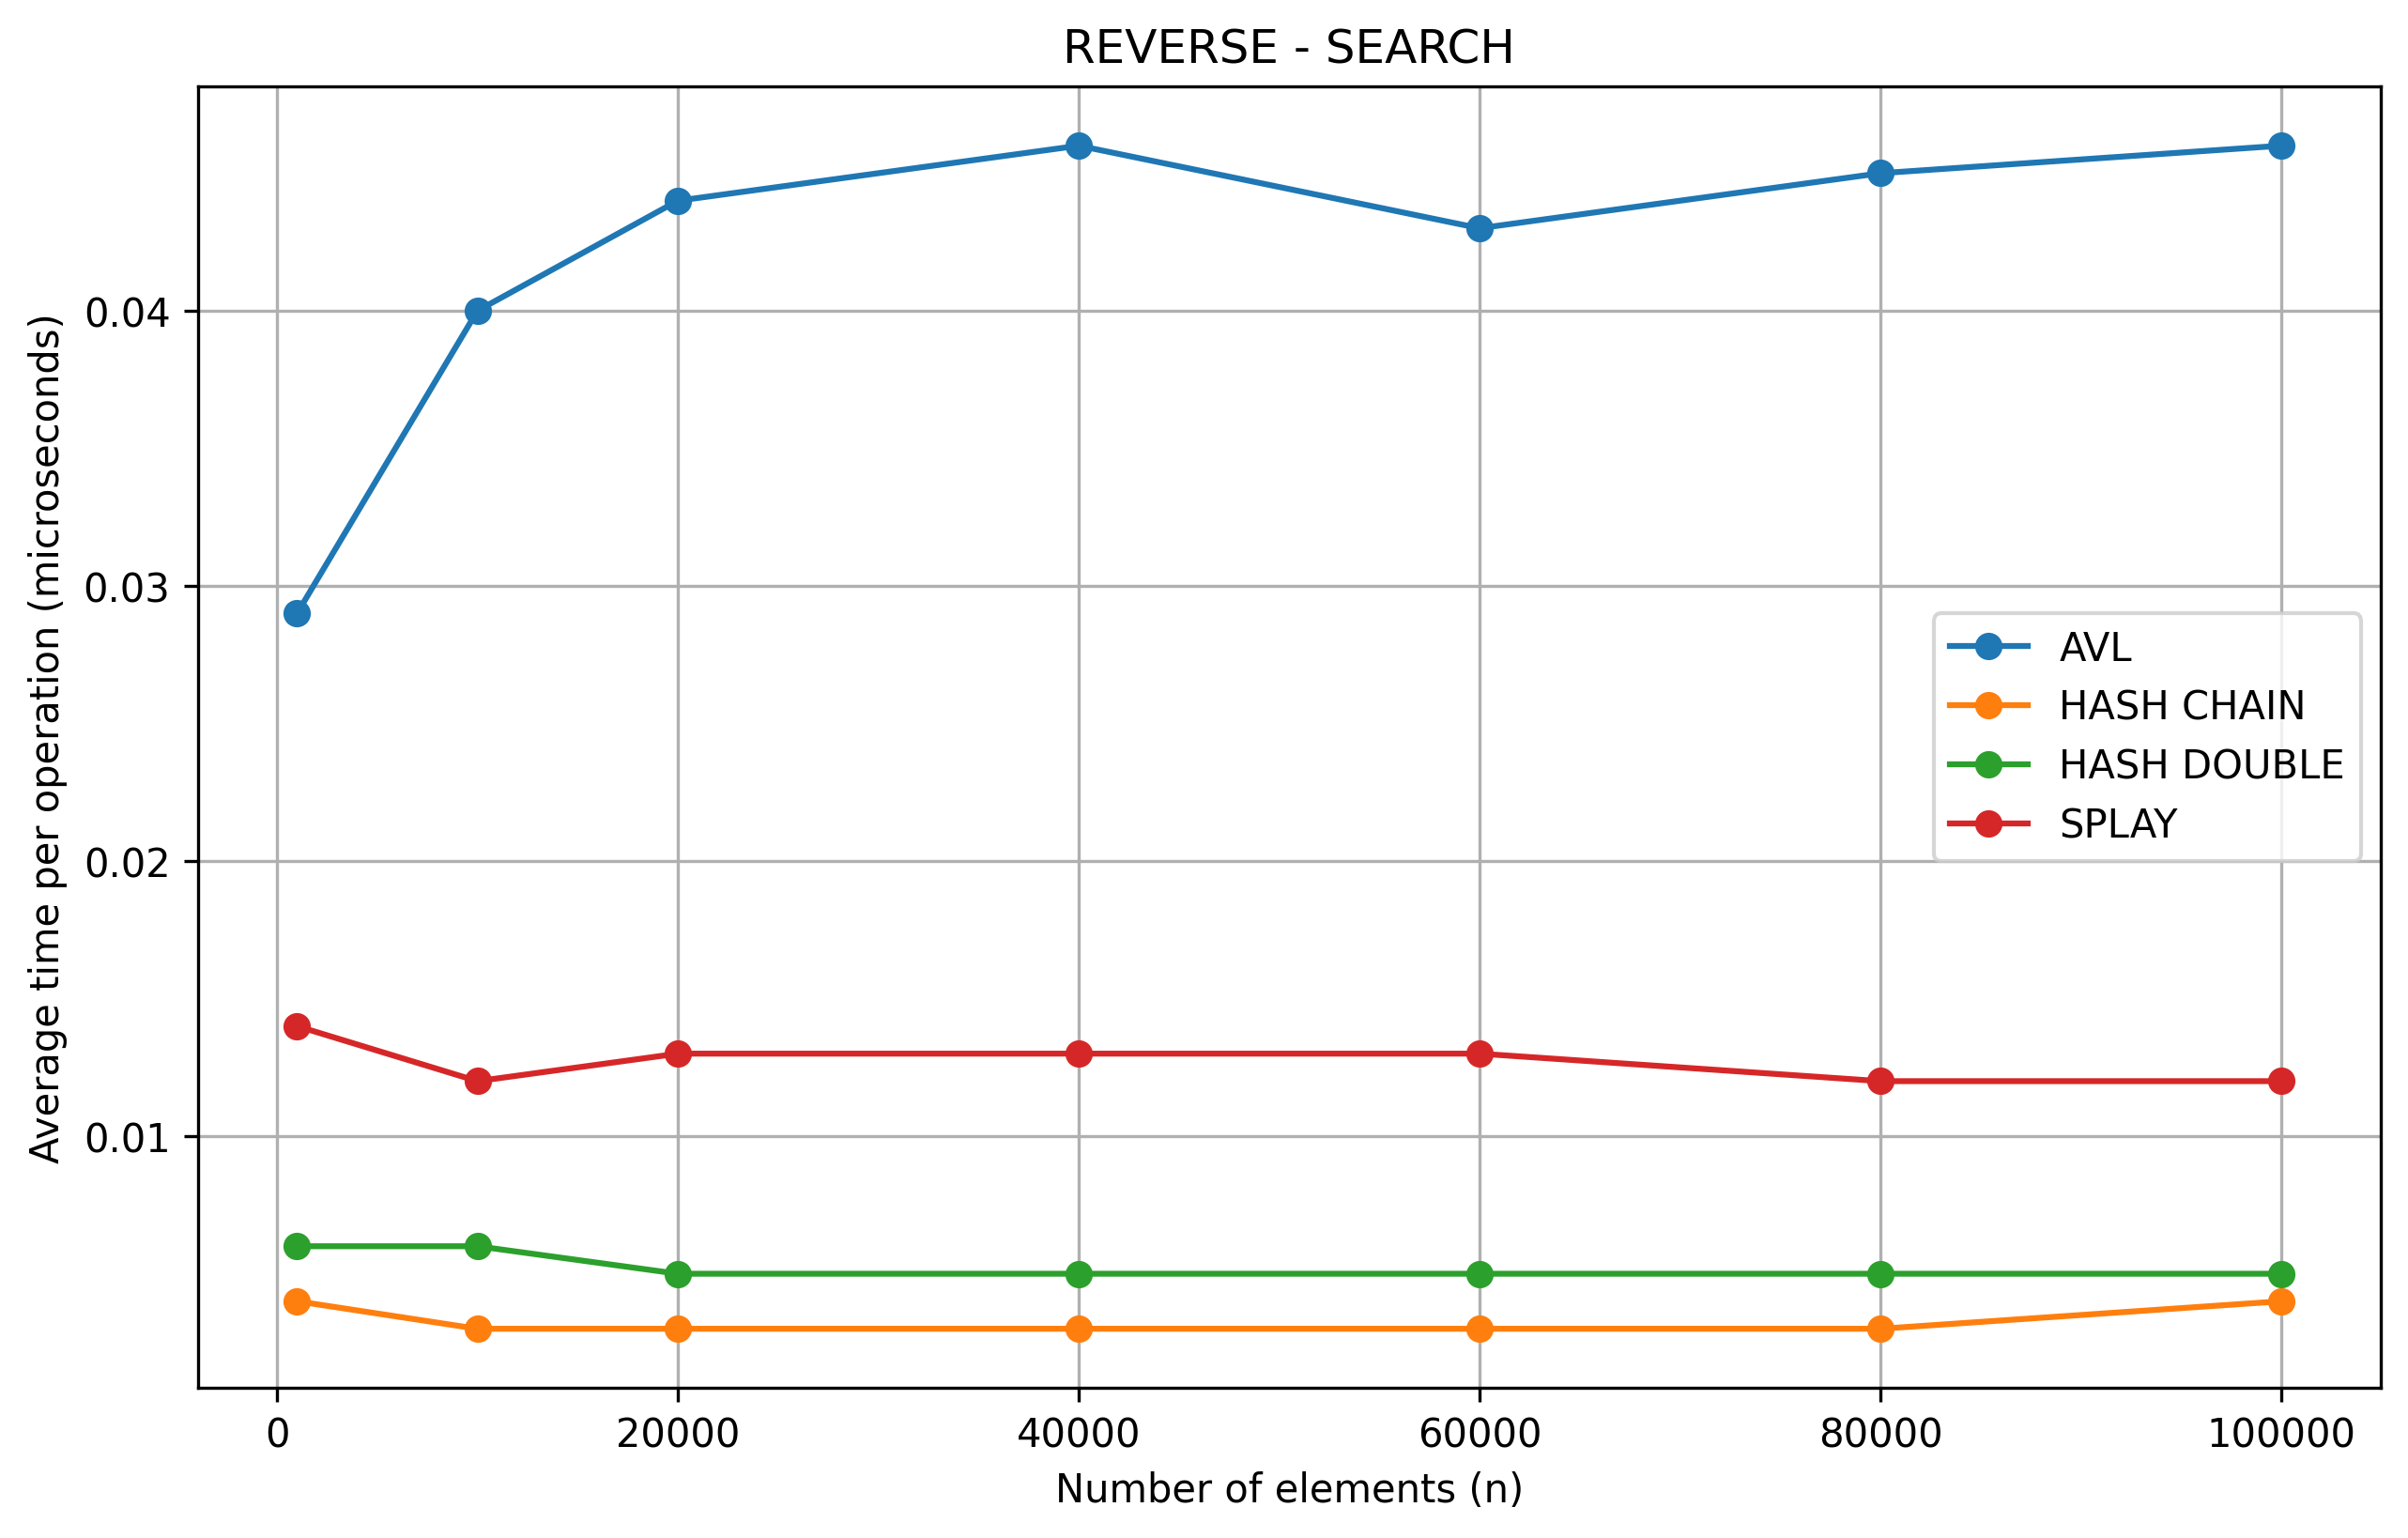
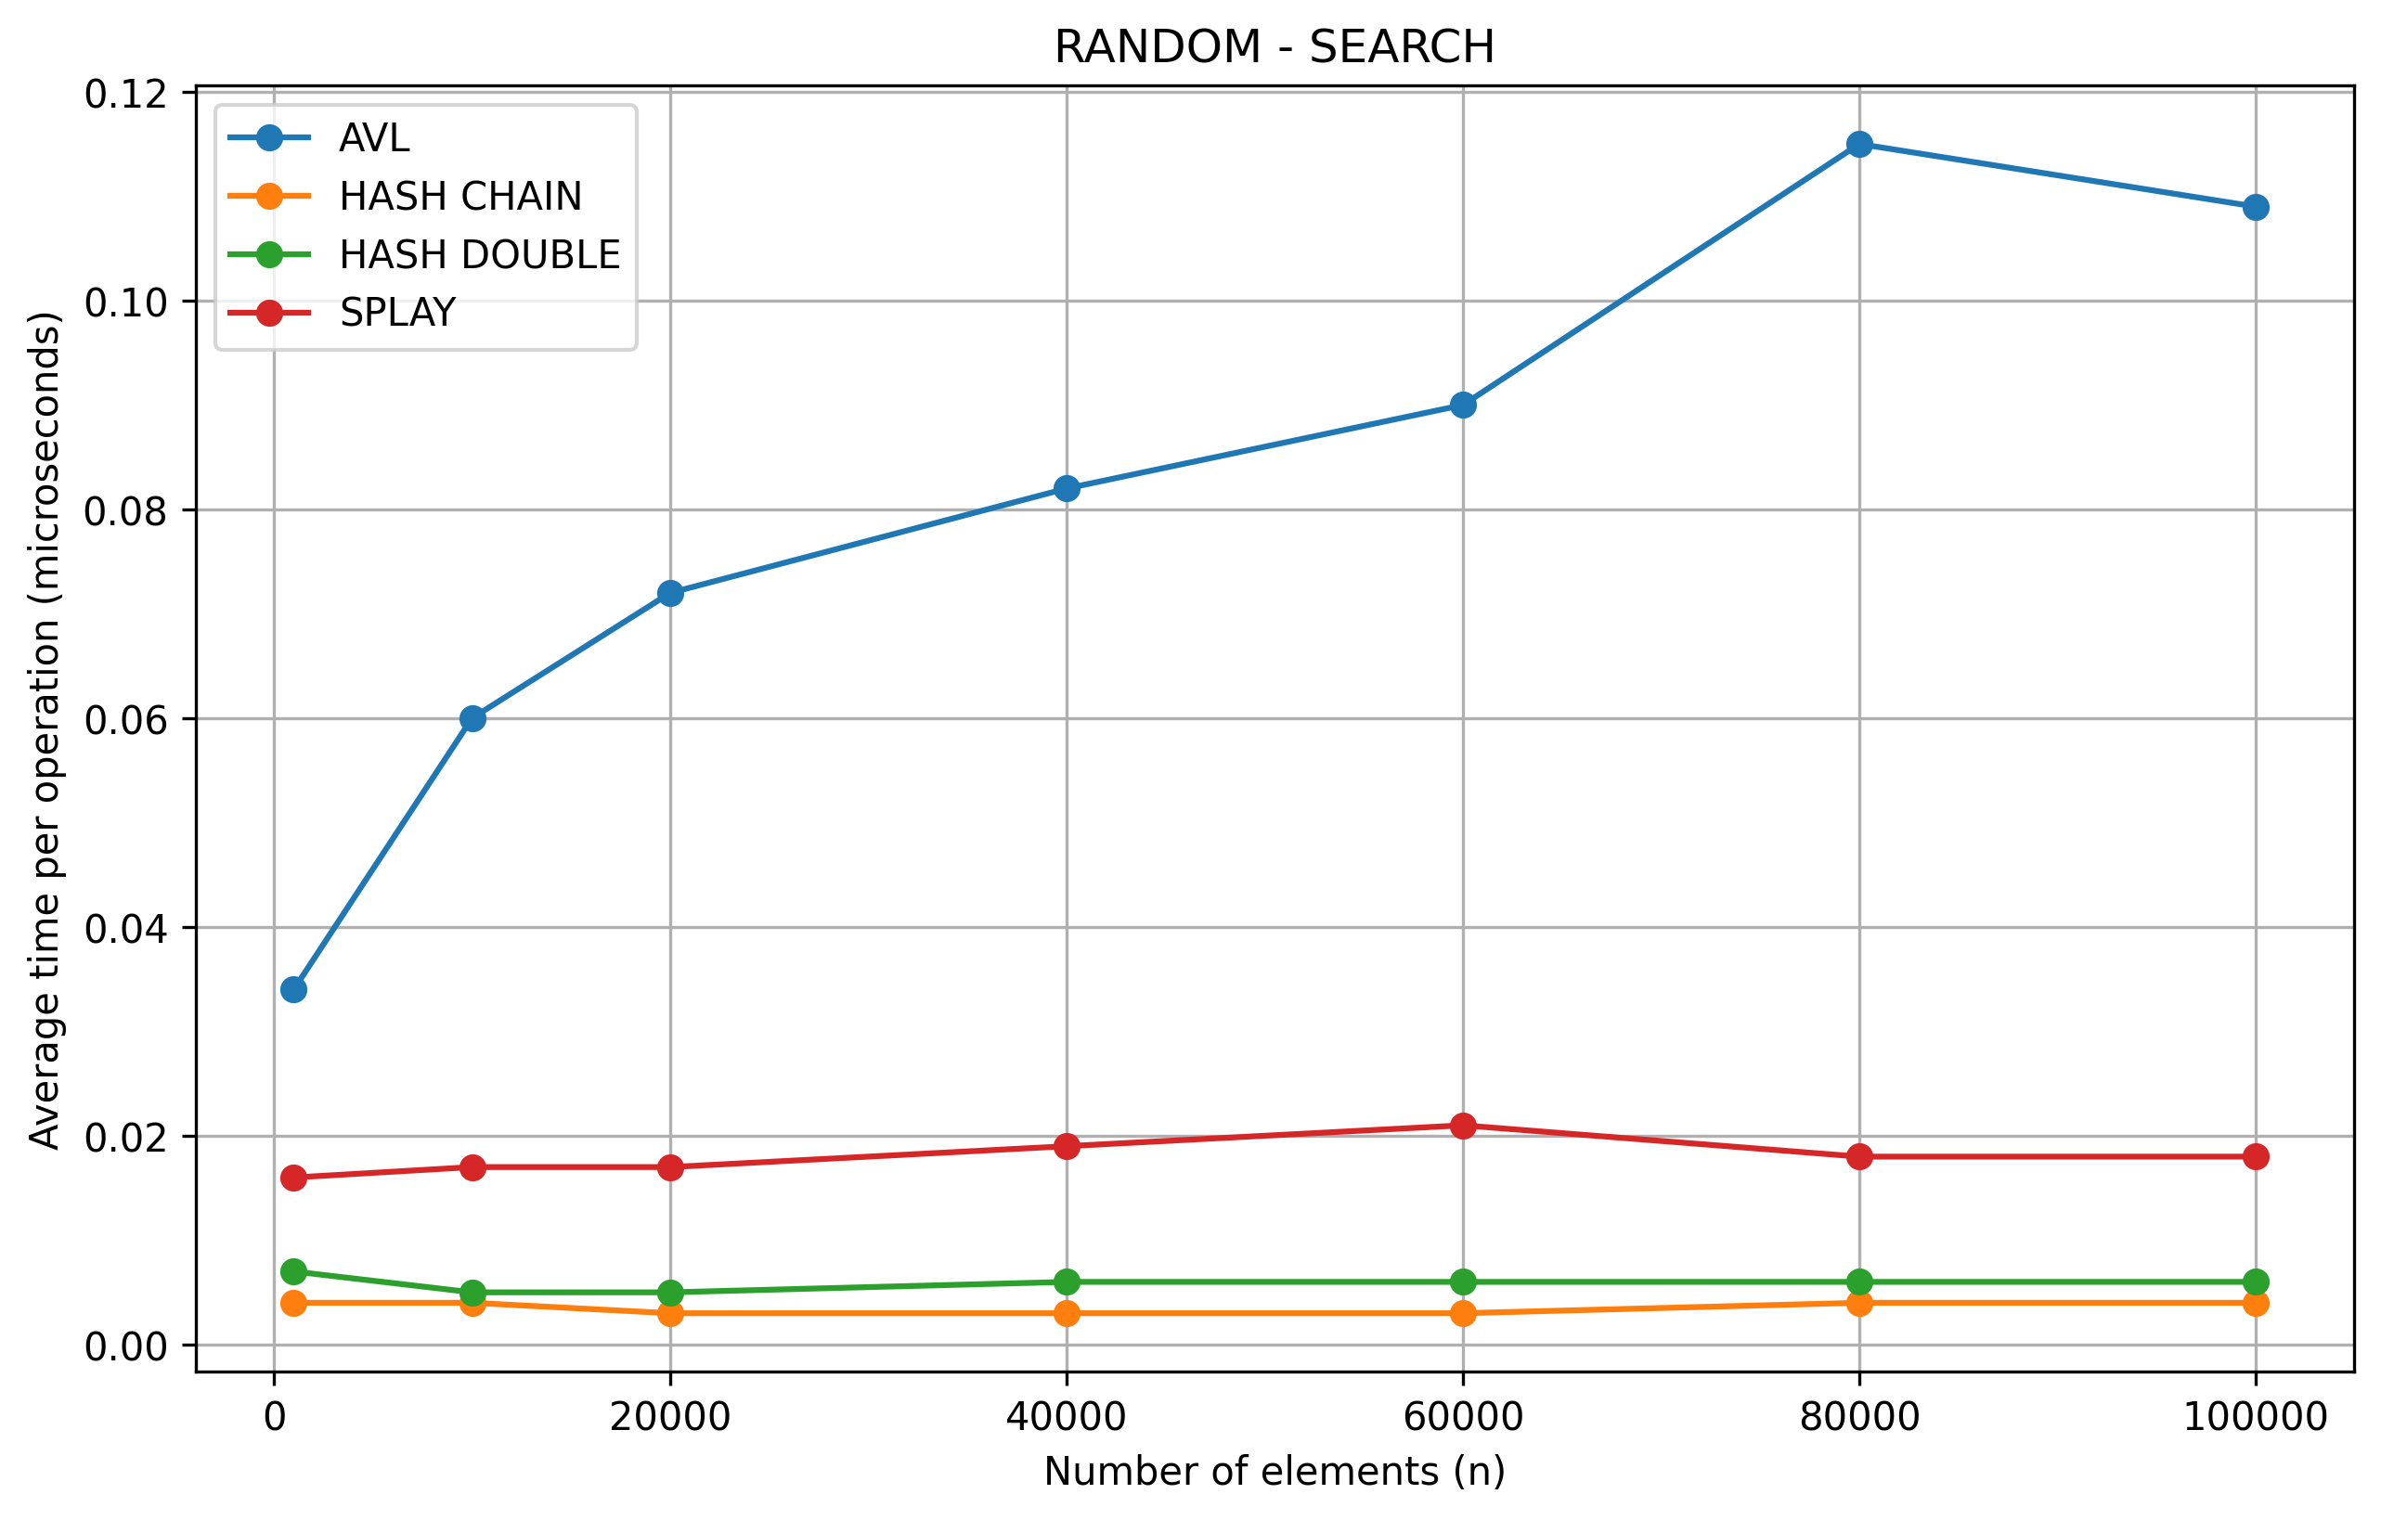
DELETE
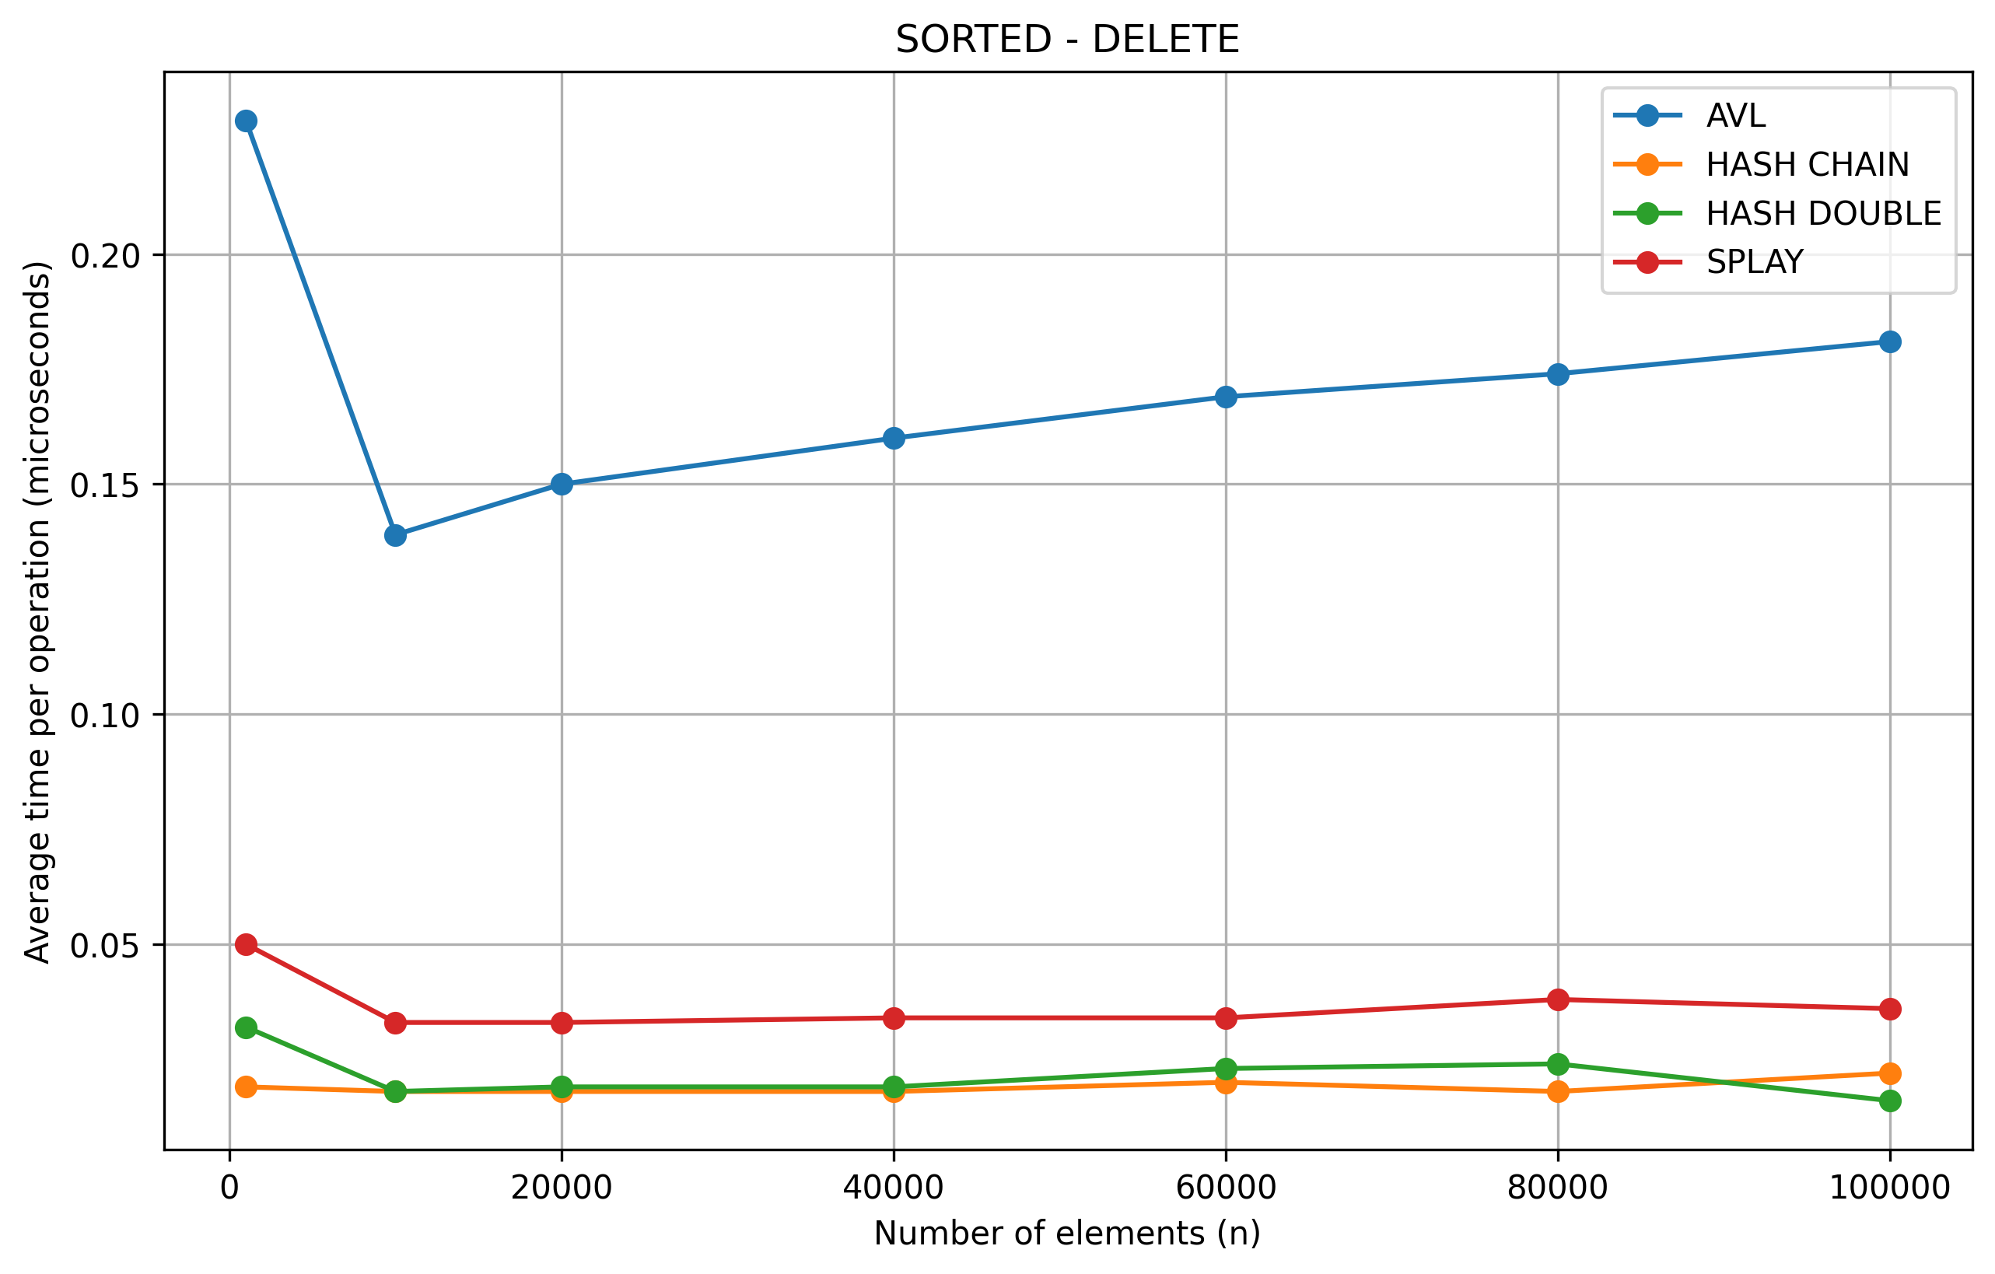

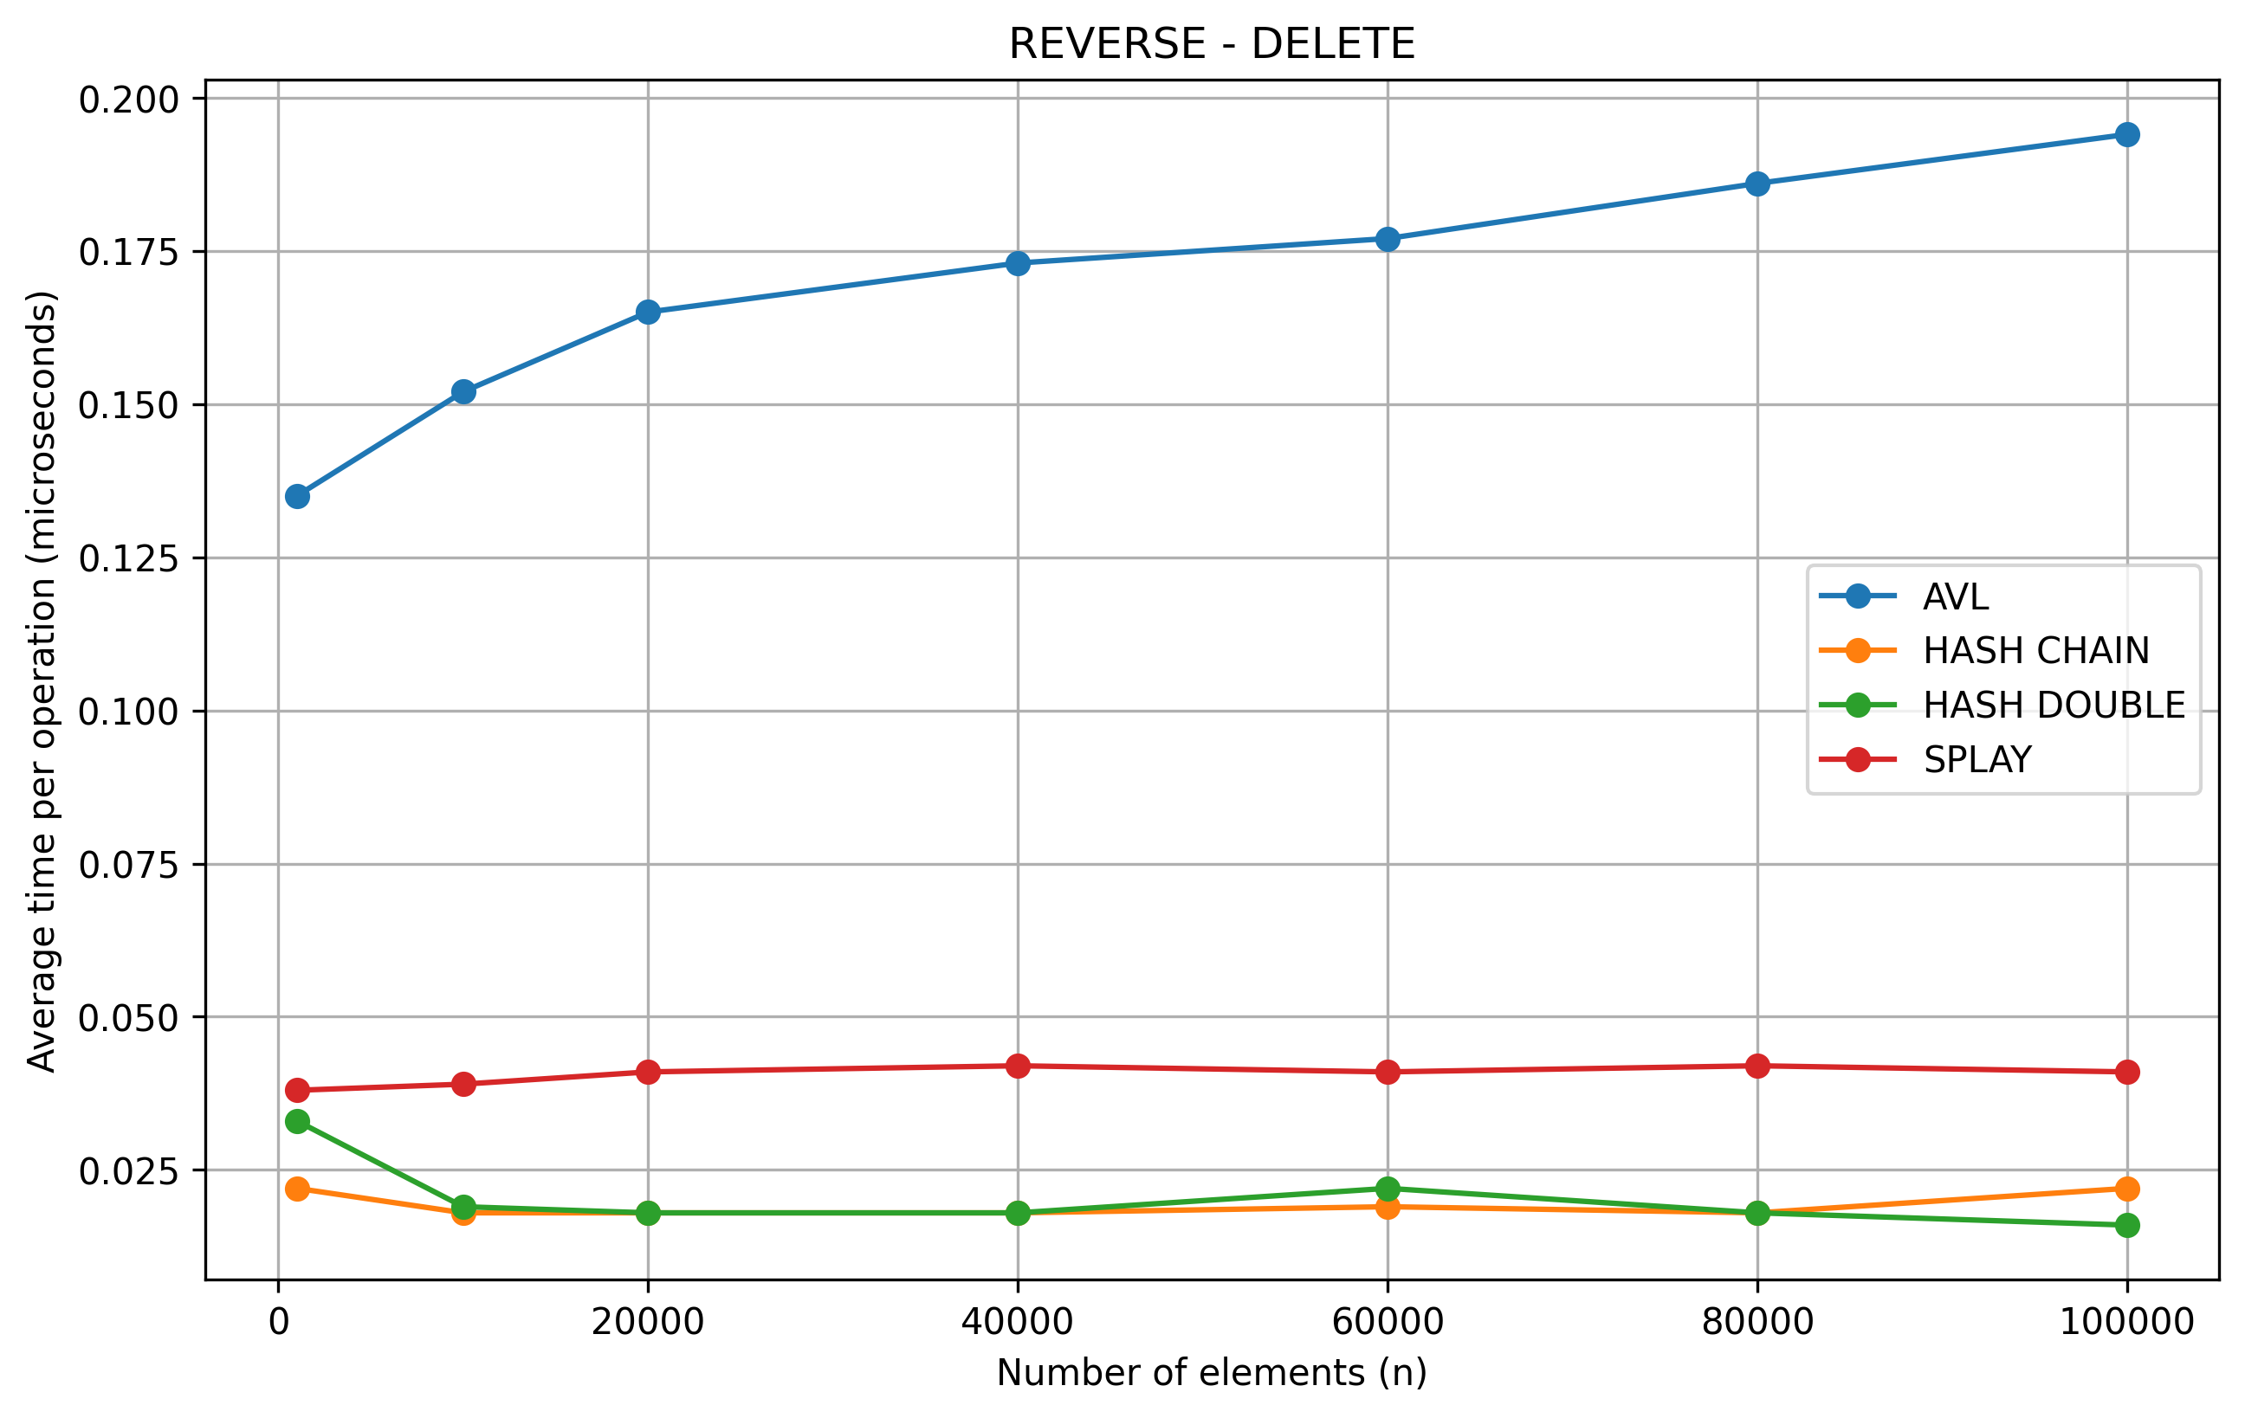
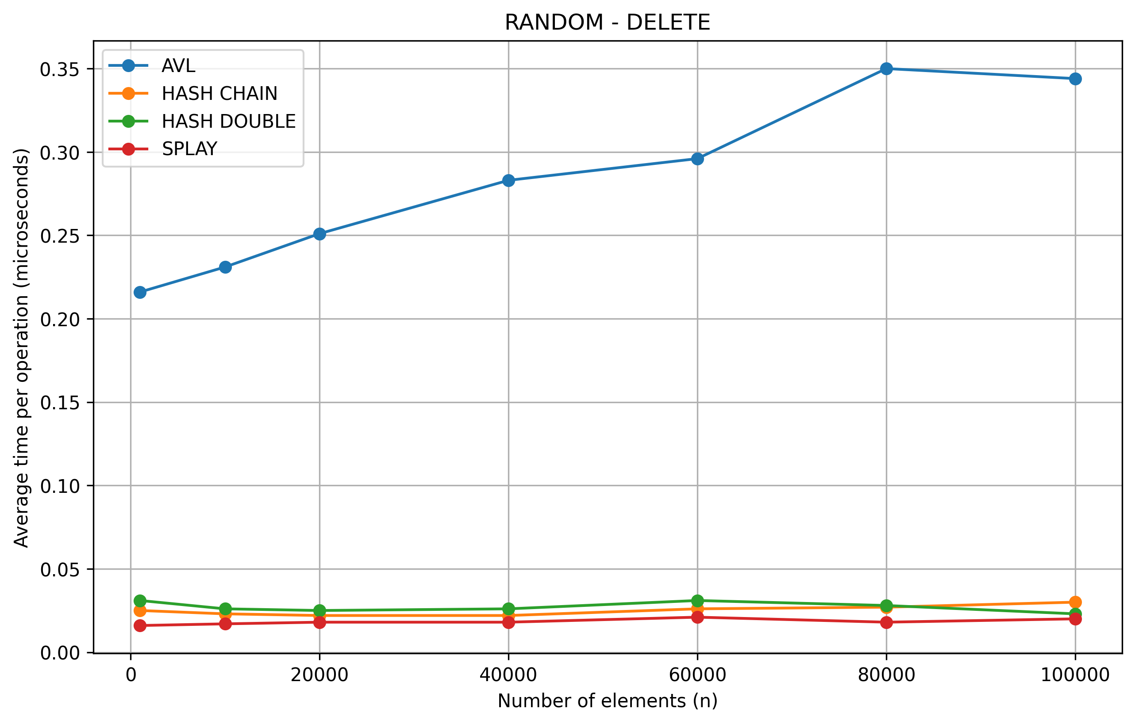

Results and Analysis
AVL Tree
The AVL tree demonstrated:
Stable performance across all scenarios
Logarithmic complexity O(log n)
Minimal sensitivity to input order
This confirms its theoretical guarantee of balanced height.

Splay Tree
The Splay tree showed:
Variable performance depending on access patterns
Good performance for repeated accesses
Worse performance for random workloads
This aligns with its amortized complexity behavior.

Hash Table (Separate Chaining)
Observed characteristics:
Near constant-time performance O(1)
Slight degradation with increasing collisions
Stable across scenarios
It performs well for large datasets.

Hash Table (Double Hashing)
Key observations:
Faster than chaining in many cases
Sensitive to load factor
Performance drops when table becomes crowded
Efficient but requires proper tuning.

Comparative Analysis
Structure | Time Complexity | Stability | Best Use Case
AVL Tree | O(log n) | High | Predictable performance
Splay Tree | Amortized O(log n) | Medium | Repeated access
Hash Chain | O(1) avg | High | Large datasets
Hash Double | O(1) avg | Medium | Memory efficiency

Key Findings
Hash tables outperform trees in most cases
AVL tree provides consistent performance
Splay tree is highly dependent on access patterns
Input order significantly affects performance

Conclusion
The experiment demonstrates that:
No single data structure is optimal in all cases
Choice depends on use case
Hash tables are best for speed
AVL trees are best for stability
Splay trees are useful for adaptive workloads

